Temasek Polytechnic
School of Informatics and IT

Diploma in Information Technology (IT)

Software Design Specifications (DS)

Project Particulars

Tutor | Mel Goh
Class | P04
Project Title | Delonix Regia Hotel Management System

Project Team’s Particulars

Matric Number | Student Name
1405306C | Parmesher Singh
1404150C | Shaun Chua
1404555C | Quinones Mark Joseph

Revision History

Date | Version | Description | Author
<dd/mm/yy> | <x.x> | <details> | <name>

Table of Contents

1. DISTRIBUTION OF WORKLOAD 4
2. ARCHITECTURE DESIGN 4
3. USER INTERFACE (UI) DESIGN 4
4. PROGRAM DESIGN 4
5. DATABASE DESIGN 4

DISTRIBUTION OF WORKLOAD
Design | Members
Design UI | Shaun Chua
Architecture Design | Mark
Database Design, Program Design | Team

ARCHITECTURE DESIG

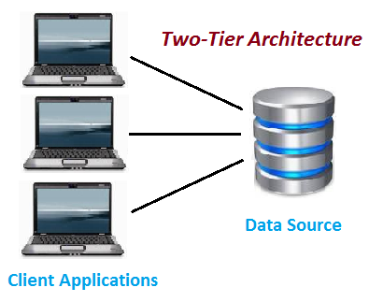

This architecture is based on a client server architecture and is like a client server application. This means that there is a direct line or communication between the client and server which means that there is no interface in between. This along with a tight coupling results in a 2 tiered application running faster.

Consist Of

Data Server/ Database

Client Application

Code is written for saving the data into the SQL server database.

Client sends request to server and processes the request and returns the data.

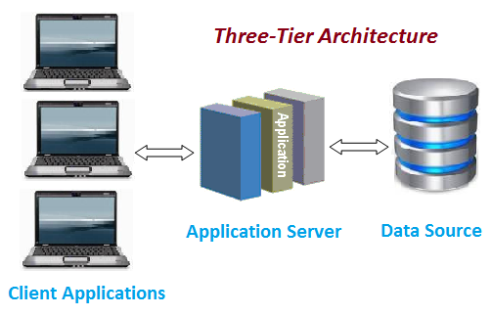

Consist Of

Client Layer

Also known as the presentation layer, this layer contains the User Interface(UI) part of the application. The main purpose of this layer is for designing where data is presented to the user or input is collected from the user.

Business Layer

In this layer, all business logic such as validation of data, calculations and etc are coded. The business layer acts as an interface between the Client layer and the Data Access layer. Because this layer helps to increase the speed of communication between the Client layer and Data Access layer, it is also known as the intermediary layer.

Data Layer

This layer encapsulates the methods to connect the database and enables the insertion, update, delete and retrieval of data from the database based on the input data.

Chosen Architecture

2-Tier Architecture

After researching and getting to know more about both 2-tier and 3-tier application. The team has decided to go with the 2-tier architecture as we feel that it is the more suitable considering the requirements that was provided to us by Mr.Wang. The following reasons why we choose this architecture are:

Cost

Taking into consideration the budget, the team has decided that a 2-tier application is better suited as it is easier to create and less complex as compared to a 3-tier application which means that a 2-tier application is cheaper so the risk of exceeding the given budget is reduced greatly.

Hardware Requirements

Based on the clients request, the system would be run on a Pentium 4 single pc that runs Windows XP 2 having only 1GB of Ram and 100GB of HDD the team has decided that making use of a 2-tier architecture would be suitable for the computers specifications as running a 3-tier architecture on that system could result in a system that would not be able to deliver the target response time as it is not powerful enough to support the more complex architecture.

Maintenance

In a 2-Tier architecture, it is easier to keep the client updated in the long run as compared to a 3-Tier architecture because if you have to update a 3-tier application some of the patches that are rolled out may not be compatible with the codes which means that an extensive change needs to be done for maintenance this leads to a longer maintenance duration. As per the requirements, the system is only allowed a downtime of 2 hours per month so every second counts while doing maintenance a 2-Tier application comes on top in this regard.

USER INTERFACE (UI) DESIGN
Windows UI. We decided to use Windows UI as it has the benefit of icon, pull-down menus and a pointer which can be easily manipulated using a mouse or maybe a keyboard to an extent. It also has an major advance over on the command line interface(CLI) of the console which only display text and only accessible using keyboard. This enable it to be easier to work with. The software impact usability also as it is quite flexible and it can be manipulated easily and intuitively(with little instruction) even if used by inexperience users.

PROGRAM DESIGN

Use Case
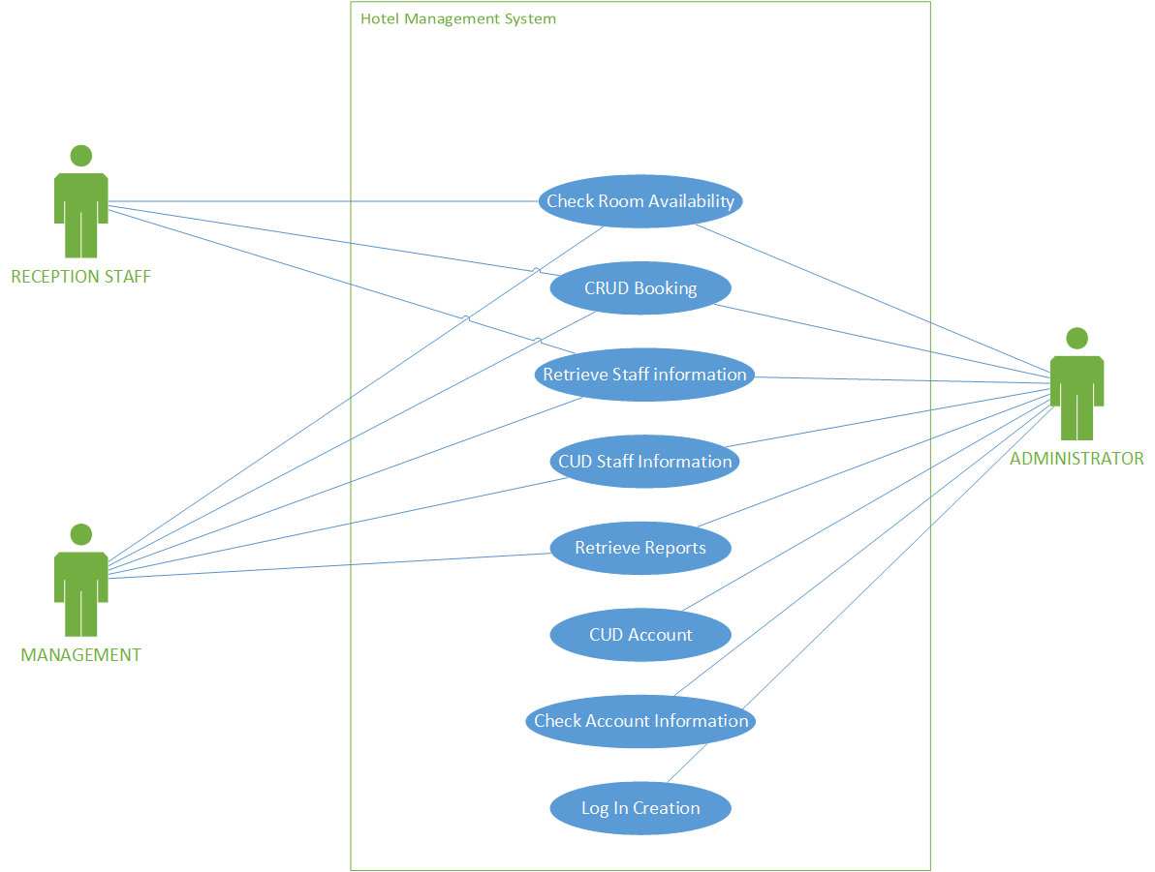
As we can see from the diagram above, the program is designed in such a way that not all of the use case can be used by all the users this is to ensure that only those with the correct authentication would be able to modify the files and ensure that data integrity doesn’t get compromised.

DATABASE DESIGN
Booking(booking_id, last_name, first_name, phone, email, address, payment_method, check_in_details)

Staff(staff_id, DOB, bank_number, address, mobile_number, duty_type)

Reports(report_id, last_name, first_name, check_in_details, booking_id)

Checkin(last_name, first_name, number_of_people, phone, email, mail_address, card_id, checkin_id, booking_id, room_id
Duration_of_stay)

Creditcard(card_id, card_number, name, expiration)

Room(room_id, rates)

The team has decided to base our database schema on Mr.Wang’s specified requirements for the 3 modules.

Class Diagram
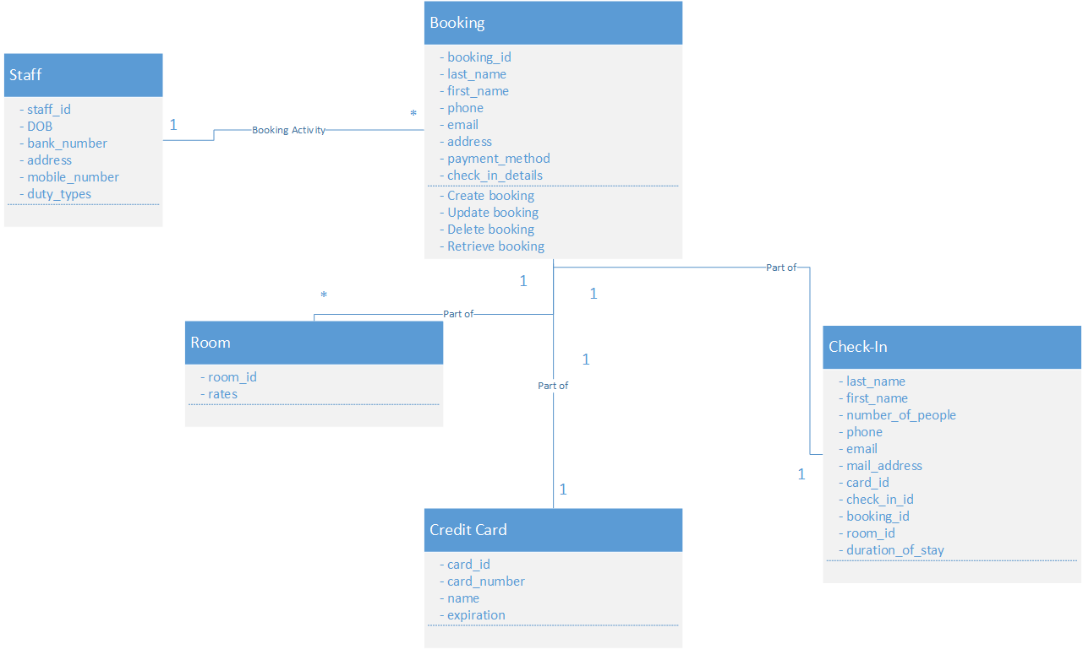

Reference

http://www.softwaretestingclass.com/what-is-difference-between-two-tier-and-three-tier-architecture/

http://docs.oracle.com/cd/B25221_04/web.1013/b13593/undtldev011.htm
http://www.codingthearchitecture.com/2012/07/20/when_do_you_need_a_3_tier_architecture.html

